**MODULE (Bootstrap Basic & Advanced) – 6**

Que-1- **What are the advantages of Bootstrap?**

Ans-1- Bootstrap offers a wide range of pre-built components, such as navigation bars, forms Buttons, And More, Saving Time and effort in coding.

Que-2-**What is a Bootstrap Container, and how does it work?**

Ans-2-In Bootstrap container is used to set the content's margins dealing with the responsive behaviour of layout. It contains the row elements and the row elements are the container of columns (known as grid system).

it wraps a page's content and set and align content within it according to device or viewport.

There are two container classes in bootstrap:

1. **.container:**

The container class provides a responsive **fixed width container.**

1. **.container-fluid**

The container-fluid class provides a **full width container**, spanning the entire width of the viewport.

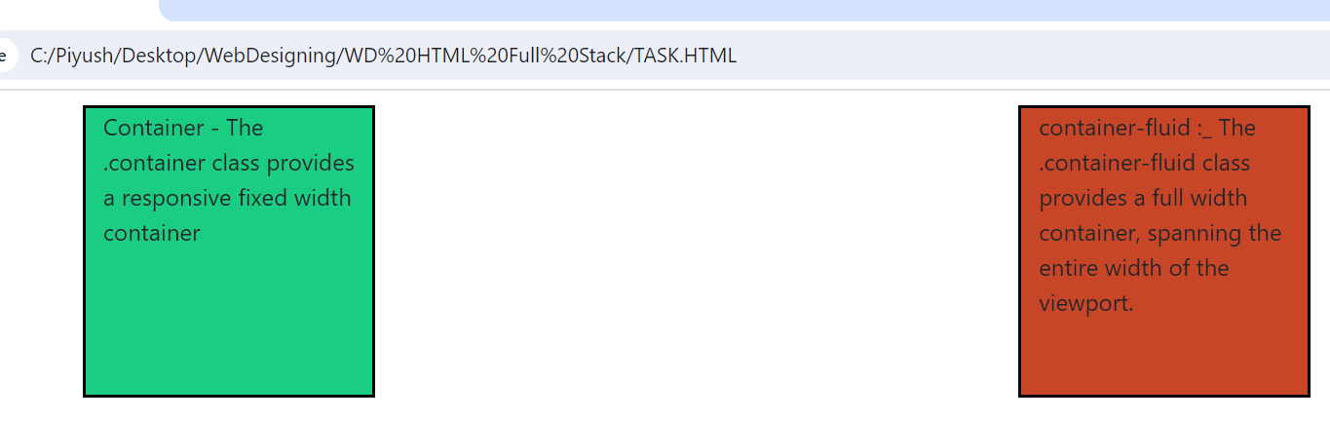

**Que-3-What are the default Bootstrap text settings?**

**Ans-3-**Bootstrap 4 uses a default font-size of 16px, and its line-height is 1.5.

**Que-4-What do you know about the Bootstrap Grid System?**

**Ans-4-**Bootstrap's grid system allows up to 12 columns across the page.

If you do not want to use all 12 columns individually, you can group the columns together to create wider columns:

**Que-5-What is the difference between Bootstrap 4 and Bootstrap 5?**

* **Ans-5-JQuery Dependency:** Bootstrap 4 relies on jQuery for certain components and functionalities. Bootstrap 5 has removed the jQuery dependency, aiming for a more modern and lightweight approach.
* **Utility Classes:** Bootstrap 5 introduces more utility classes, making it easier to apply styles directly in the HTML without the need for custom CSS.
* **New Components:** Bootstrap 5 includes new components like Off canvas, which provides a flexible and customizable way to create sidebars and modals.

**Que-6-What is a Button Group, and what is the class for a basic Button Group?**

**Ans-6-**In Bootstrap, a button group is a class called "btn-group" that groups a series of buttons vertically or horizontally without spaces. The basic syntax for a button group is <div class="btn-group"> <button type="button.... Each button has its own class of "btn". For example, you can wrap a series of buttons with .btn in .btn-group.

**Que-7-How can you use Bootstrap to make thumbnails?**

**Ans-7-**To create thumbnails using Bootstrap, you can:

1. Include the Bootstrap and jQuery CDN into the head tag before all other stylesheets
2. Create a div tag in the HTML body
3. Create three div sections for each image in the div tag
4. Add <col-sm-6 and <col-md-3> to four div sections to make the webpage responsive
5. Add <a> tag with class value thumbnail to define the link of the image in the next line .

**Que-8-In Bootstrap 4, what is flexbox?**

**Ans-8-**In Bootstrap 4, flexbox is used to control the layout and alignment of components. It makes it easier to design responsive layouts without using positioning or floats.

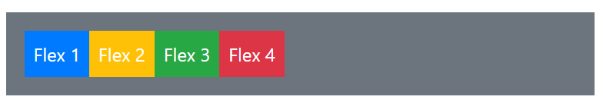

**Que-9-How can one create an alert in Bootstrap?**

**Ans-9-**We will use the . alert class along with the contextual classes that are used to display the alert message in the application.

The alert classes like . alert-success, . alert-info, . alert-warning, . alert-danger, . alert-primary, . ...

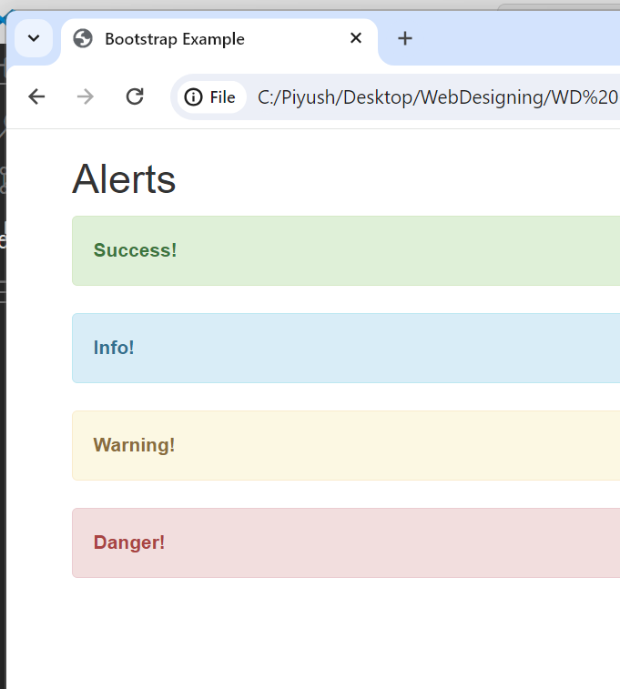

**Que-10-What is a bootstrap card and how would you create one?**

**Ans-10-**Bootstrap cards are flexible containers that can be used to hold content in rows. They can contain images, text, list groups, links, headers, footers, and background colours. Cards are built with flexbox, which makes them easy to align and mix with other Bootstrap components.

